Asia-China-Mirror-8 Leaf-Arc-Beast

**Mirror, Early Western Han dynasty (206 BCE-9 CE).**

**Originally white metal, but now gray-black. Design: 16 continuous rim arcs, inner square and 8 leaves (caoye); 4 nipples at the cardinal directions, mythical beast at the central knob. Eight leaf, 16 arc and 4 nipple configurations, which appeared at the end of the Warring States period, depict a cosmological scheme: the arcs indicate the sun's cycle, and the nipples indicate the cardinal points of the compass to point the way.**

**There are also 16 designs on either side of the four cardinal bosses. These have been interpreted as either "birds with spread wings" (**Swallow (1977:44) or as "a 'caoye', or grass and leaf, pattern ... defined by the symmetrical motif resembling an ear of corn" (Menzies 2003:74). It has also been suggested that **the leaf designs may be derived from the Shang *taotie*** 饕餮 , all-devouring b**east, suggesting a mysterious communication with Shang Ti (heaven's order).**

**The square central motif recalls a Ch'in brick according to** Swallow (1977:44) **. The central square rests on four petals, while the outer square rests on 4 trefoils. Each of the four cardinal bosses rest on one petal.**

**These design elements are consistent with the eight-character inscription: " May one's vision be enlightened by the sun, with the heavens as a guide. May one's vision mature in harmony with the great panorama [of the cosmos]."** Swallow (1977:32) translated the inscription as " See the Sun's light, the Earth's great brightness." On p. 44 the same inscription is translated as: "See the Sun's light which brightens the whole world." We have emphasized the hortatory nature of the inscription that beseeches the viewer to reflect on the wonder of the sun as it enlivens the world around, as the viewer matures in harmony with the scene. Menzies (2003:74) has another interpretation: "may you see the light of the sun and may the world enjoy great lightness." This could be either cosmogonic or political in meaning, or both. Swallow (1977:44) mentioned that the Sun's light may be a reference to the emperor.

**The design also presages the celestial pattern of the *liubo* gaming board and the "TLV" design of the later Western Han dynasty, placing this mirror at about 100 BCE. A very similar mirror dated to the same period is in the Art Gallery of New South Wales (Menzies 2003: 74). A similar mirror (with 16 continuous rim arcs, inner square and 8 leaves) is in the Donald H. Graham, Jr., Collection. It differs since it adds the "L" of the "TLV" design element, which dates it to the later Western Han dynasty (Nakano 1994: 112-113). Another, very similar example is also in the Beijing National Palace Museum (National Palace Museum 1986: 72-73) where the inscription is mere presented but not expanded.**

|  |  |  |  |
| --- | --- | --- | --- |
| **Left line (West)** | **Right line (East)** | **Top line (North)** |  |
| **日 be enlightened by the sun** | **天 with the heavens** | **己 May one's**  **火 vision [inverted]** | **大 with the great** |
| **己 May one's**  **目 vision** | **引 as a guide** | **禾 mature in harmony** | **睊 panorama [of the cosmos]** |

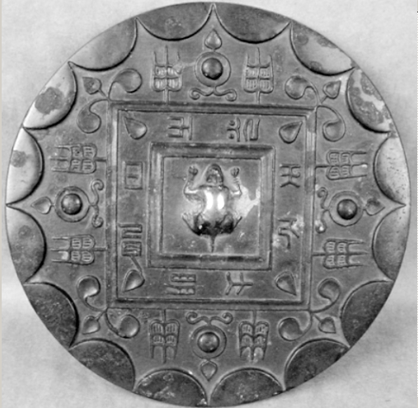

Mirror with 'caoye' design [1[st century BCE](http://www.artgallery.nsw.gov.au/collection/search/?period=china.han-dynasty-206-bce-220-ce)], Atlantica Collection.

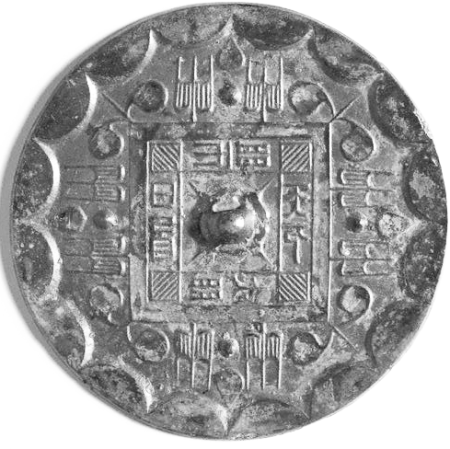

Mirror with 'caoye' design [1[st century BCE](http://www.artgallery.nsw.gov.au/collection/search/?period=china.han-dynasty-206-bce-220-ce)], Art Gallery of New South Wales(Menzies 2003, p. 74).

References: Toru Nakano, *Bronze Mirrors from Ancient China* ([Hong Kong]: Orientations, 1994; Jacqueline Menzies, "Mirror with 'caoye' design [1[st century BCE](http://www.artgallery.nsw.gov.au/collection/search/?period=china.han-dynasty-206-bce-220-ce)]," *The Asian Collections: Art Gallery of New South Wales* (London : Thames & Hudson, 2003); Robert W. Swallow, *Ancient Chinese bronze mirrors*. Rev. and enlarged ed. by Fred Belcher. Ann Arbor: Ars Ceramica, Ltd., 1977, p. 32; National Palace Museum *Gu gong tong jing te zhan tu lu* = Catalogue of the special exhibition of bronze mirrors in the National Palace Museum (Taipei: Guo li go gu gong bo wu yuan, Minguo 75 [1986]).